www.gayatrirubberindustry.com



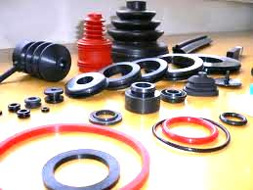

Gayatri Rubber & Fibre Plast Ind. is the largest manufacturing & Supplying Rubber Products Company . Deals in Various Type of Rubber Products, Natural Rubber , Nitrile Rubber , Silicone Rubber , Neoprene Rubber , Synthetic Rubber, EPDM Rubber & Viton Rubber. Company concentrate on supply the better quality product .

www.gayatrirubberindustry.com

www.gaytrirubberindustry.com

www.gayatrirubberindustry.com



Profile

Gayatri Rubber Industry was established in 1984, Gayatri Rubber Industry has  successfully meets the requirements of thousands of customers in industries such as Dairy Plants, Water Plants, Power Plants, Building and Constructions, Textiles Engineering, Electronics, Sporting Goods, Chemical Industries, Automobiles and

Road Construction Industry, Customers can rely on Gayatri Rubber & Fibre Plast Industry.

|  |
| --- |
| Manufacturing Rubber Products ‘O’ Ring , Gaskets, Chevron Set, ‘V’ Seals, Rubber Strip, Rubber Extruder Products, Rubber Squeegee, Bushes, Rubber to Metal Mould Products, Rubber Bellow , Anti Vibration Mounting Pad, Engine Mounting,Rubber Bush, Conveyor Belt, Rubber Sheet in Nitrile Rubber , EPDM Rubber , Silicone Rubber, Synthetic Rubber Neoprene Rubber , Viton Rubber , Natural Rubber Neoprene Rubber, Synthetic Rubber, Customize Products etc.    We have our technically Dia making team & in House Dia Making Facility, Injection Molding Machine, Hydraulic Machine, Mixing Mill, Kneader, We have Arrangement for provide Rubber Testing Report , we are concentrate on better quality product. |
|  |

www.gayatrirubberindustry.com



Rubber Parts

With the help of our well equipped manufacturing unit, we are designing and developing a wide range of rubber Product. These are widely used in automotive industry and available in different dimensions.

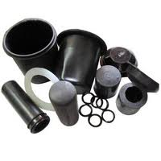 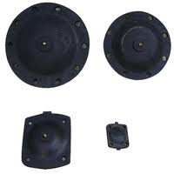

**Rubber** Parts **Packing**

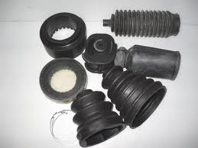 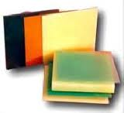

**Rubber Bellow Polyurethane Products**

www.gayatrirubberindustry.com



Silicone Rubber Products

We offer a wide range of silicone rubber products, which are resistant to extreme

temperatures. These come with features like tensile strength, elongation, tear strength,

chemical resistance and others. Furthermore, our range is suitable for medical applications and in medical implants.

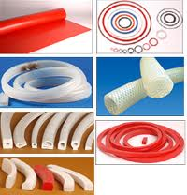 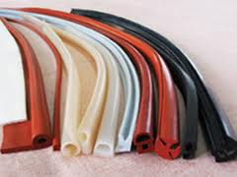

**Silicone Rubber Cords & Profile Extruder products**

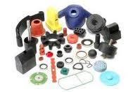 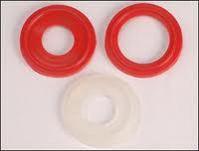

**Silicone Moulded Product Silicone Rubber Gaskets**

www.gayatrirubberindustry.com

www.gayatrirubberindustry.com

www.gayatrirubberindustry.com



Rubber Sheets :

We offer a wide range of rubber sheets, which are available in different

thickness,diameter, length and color. These are suitable for use in orthopedic footwear, industrial and mining applications.

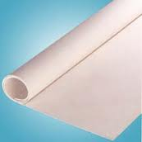 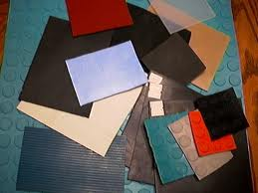

**EPDM Rubber Sheets Industrial Rubber Sheets**

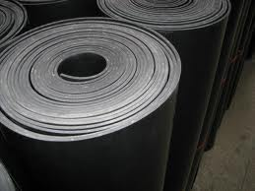 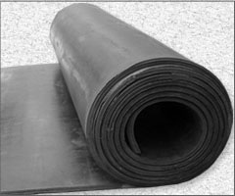

**Neoprene Rubber Sheets Natural Rubber Sheets**

www.gayatrirubberindustry.com

www.gayatrirubberindustry.com



Rubber Moulded Product

Rubber to metal molded product.

www.gayatrirubberindustry.com

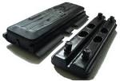 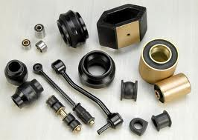

**Rubber Track Pad Rubber to Metal Bonded.**

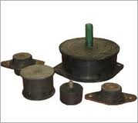 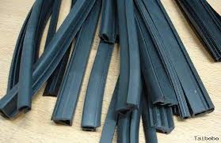

**Anti Vibration Mounting pad Rubber Profile**



Antivibration Mounting pad

We are manufacturing standard quality & high tensile Antivibration mounting pad, we are manuafcturing for special purpose also .

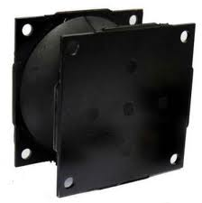 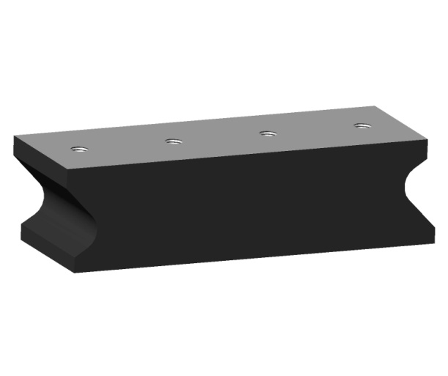

Vibarting Roller pad Vibrating Roller pad.

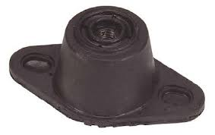 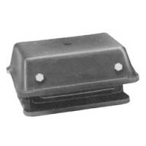

Combi Mount Cushyfoot Mount

www.gayatrirubberindustry.com

www.gayatrirubberindustry.com

www.gayatrirubberindustry.com



Other Rubber Products

We are manufacturing & Supplier Rubber ‘O’ Rings, Rubber ‘V’ Seals , Rubber Diaphragm, Rubber Bumper etc.

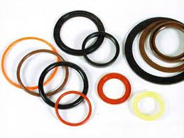 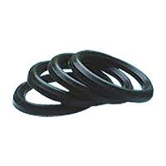

**‘O’ Rings ‘V’ Seals**

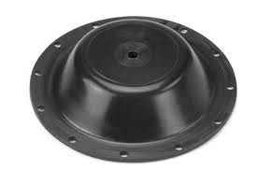 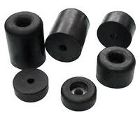

**Diaphragm Rubber Bumper**

www.gayatrirubberindustry.com

www.gayatrirubberindustry.com

www.gayatrirubberindustry.com



Contact Detail

**Gayatri Rubber & Fibre Plast Ind.**

www.gayatrirubberindustry.com

**C-1/39/12, Near Mazda ltd,**

**G I D C , Naroda, Ahmedabad-382330.**

**Mo: 98255 04863 / 98250 15706**

**E-mail : gayatrirubber1@gmail.com**

[**gayatri_rubber@rediffmail.com**](mailto:gayatri_rubber@rediffmail.com)

[**www.gayatrirubberindustry.com**](http://www.gayatrirubberindustry.com)